# Triton installation

## Accessing the software

Figure

Triton software is included on the thumb drive that is distributed at the conference. It may also be downloaded from:

<ftp://cetus.ucsd.edu/public/Software/SCMMW_2012/>

Compiled versions are currently available for Windows 7 32 and 64 bit (Win7X64 and Win7i86 respectively), and Windows XP 32 bit (WinXPi86). A Matlab source code version may be found in directory triton1.81.20120130 and requires Matlab to run. For all versions, logging functionality currently depends on having Microsoft Excel installed on the machine. Macintosh and Unix users can run triton in a virtual machine that has Windows and Microsoft Excel installed. We are currently exploring solutions to remove the dependence on Microsoft Excel.

Download the files appropriate to your architecture or locate them on your USB drive. An example for Windows 7 64 bit via the Internet can be seen in Fig. 1. For compiled versions, you will need to download the MCRInstaller, the Detection Effort template, TritonHelp, and the triton executable. For the source code version, download all files.

## Software installation

### Compiled versions

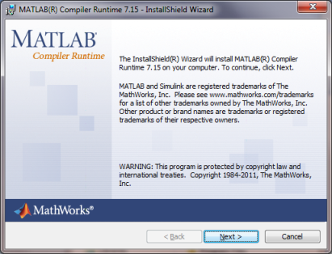The first step is to launch the Matlab compiler runtime software (MCRInstaller) that provides support for the compiled version of Triton. The installer may install support libraries (VCREDIST) prior to starting installation of the Matlab runtime environment (Fig. 2). Subsequent dialog windows will prompt you for customer information (you can put anything you want) and provide a default installation location that you may change before installing the runtime system.

Figure

The remaining files, the Detection Effort template, TritonHelp and triton.exe should be placed in a folder of your choice. Double click on the triton to start.

### Source code versions

All of the files should be downloaded and placed in a folder of your choice. Start Matlab, and use the path manager to add the directory to your search path. Detailed instructions on how to do this are in the TritonHelp file.

### A note on the logger functionality

The logger function of triton currently uses a Microsoft protocol to communicate with Microsoft Excel. It only functions on Windows platforms and requires Excel to be installed. We are working on developing a solution to create workbooks that does not require proprietary software.